Determining Age in the Skeleton

Objectives
- Describe ways to estimate age at time of death in subadults and adults.

Age Estimation (provide the definition)
- ______________________________________________________________________________________________________________________________________________________

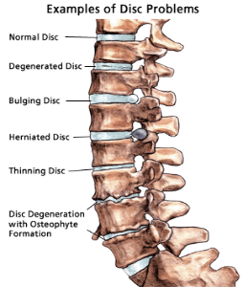
Age in Adults and Subadults
- Is it harder to estimate age in adults? ___________________________________________________________________
- Are different periods of life are easier to determine age than other periods of life?
  - __________________________________________________
  - __________________________________________________
- After age 25-30 the teeth are in and bones fused are fused. How can we estimate the age then? _____________________________________________________

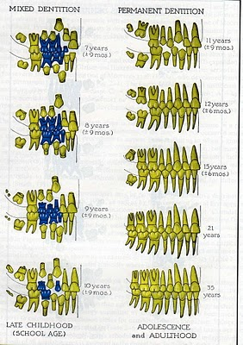
Subadult Age Estimation
- Tooth Eruption: Give an age range
  - __________________: all baby teeth (20) appear
  - __________________: permanent teeth (32) appear
- What is the dental formula for a subadult?
- How many are present of each?
  - __ incisors
  - __ canine
  - __ premolars
  - __ molars
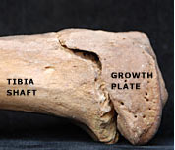
- Long bones: Give the definitions.
  - ___________________ or shaft: long part of bone
  - ___________________ ends of bones
- What happened when long bones fuse? What does it mean? _____________ _____________________________________________________

Adult Age Estimation
- What is the dental formula for an adult?
  - ______________________________
- How many are present of each?
  - __ incisors
  - __ canine
  - __ premolars
  - __ molars
- Tooth Wear, give one example:
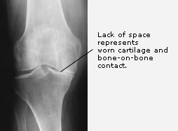
- ________________________
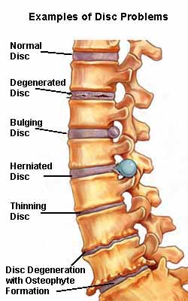
  - Following period of union of epiphyses; mid-20s and older, degenerative changes in many of the joint surfaces

Review
Describe ways to estimate age at time of death in subadults:

Describe ways to estimate age at time of death in adults:

Age in the Skeleton

- When an age estimation is given, what does it refer to?

- Why is it harder to estimate an adults age compared to a subadult?

- At what age are all teeth in and bones fused?

- What is Diaphysis?

- What is Epiphyses?

- What can be said after long bones fuse?

- At what age is lipping pronounced?

